Report for Assignment 1

Question 1

1. This code is saved in 1_1.py
2. This program allows the user to input the final account value, annual interest rate (the unit is %) and the number of years.

These numbers should be positive real numbers.

The output would be the initial value of money that has to be saved to obtain the final account value.

1. Execute as followings:

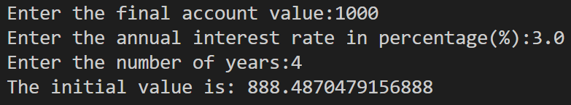

Question 2

1. This code is saved in 1_2.py
2. The program prompts the user to enter a number

The number should be a positive real integer.

The output will show digits of the number one by one.

1. Execute as followings:

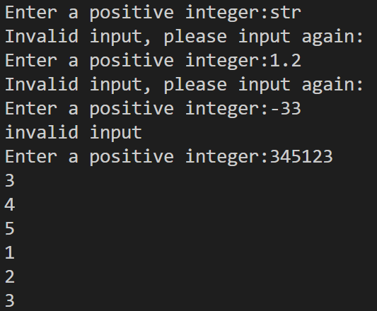

Question 3

1. This code is saved in 1_3.py
2. Input a number to find the smallest integer n such that n 2 is greater than the number.

The input must be a positive number.

Output is n

3.Execute as followings:

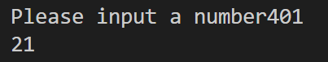

Question 4

1. This code is saved in 1_4.py
2. The program allows the user to input a number N

The number N must be a positive integer.

The output is a table with N rows and 3 columns. In the **m**th row, your program should output three numbers: **m**, **m+1**, and **m(m+1)**

3.Execute as followings:

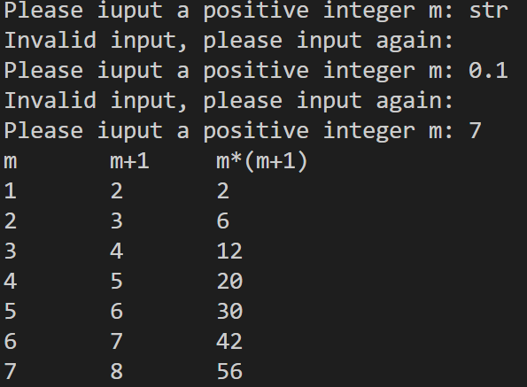

Question 5

1. This code is saved in 1_5.py
2. input an integer N

N must be a positive integer bigger than 1.

Output: all the prime numbers which are smaller than N.

3.Execute as followings:

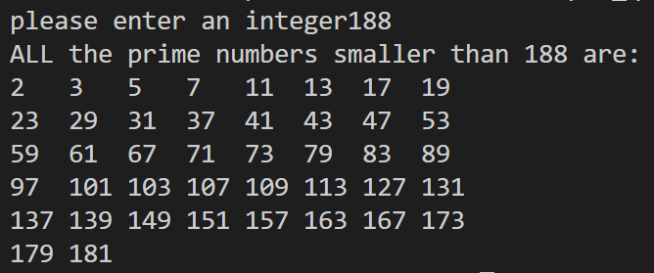

Question 6

1. This code is saved in 1_6.py
2. The user can specify a trigonometric function f (f can only be sin, cos or tan), and input the interval end points a, b and number of sub-intervals n.

“a” must be smaller than “b”, and a, b and n must be integer, and n should be positive.

Output: the numerical integration of f over [a, b]

3.Execute as followings:

